Web Portfolio Planning 1.0
- HTML
  - Home
  - Projects
    - Project title
    - Screenshots
    - What I’ve learned
    - files
  - about me
  - skills
  - contact info
- CSS
  - Background
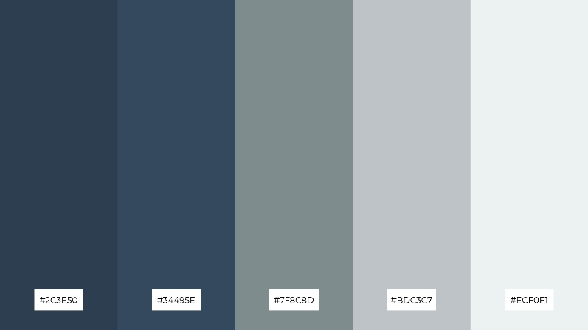
  - Menu design
  - Headings
- JS functionality
  - -

